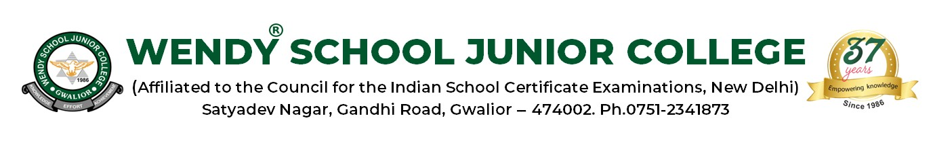

CIRCULAR

WSJC/TEACHER CIRCULAR No.5/2023-24 DATE-25/08/2023
Dear Teachers,
Please announce in the class the following details

Date | Class | Activity
26/08/2023  ( Saturday) | Grade 6-7 | Declamation on Great Women on Planet( 1st Period)
 | Grade 8 | Declamation on Great Women on Planet ( 2nd Period)
 | Grade 9-12 | Skit on Women Equality (4th Period) after 4th Period Class 11 & 12 will go home.
28/08/2023  ( Monday) | Grade 1-5 | National Sports Day- Spoon Race, Lemon Race, 100 mts Race, Obstacle Race and Three legged Race( 1st- 3rd Period)  Note: everyone will wear Sports Uniform
 | Grade 6- 8 | Rakhi Making Activity( 6th Period)
 | Grade 9-12 | National Sports Day – Volley Ball Match between two teams – First team – Grade 9-10 Vs Second Team-11-12  ( 5th -6th Period)  Note: everyone will wear Sports Uniform
29/08/2023  (Tuesday) | Grade 1-5 | Rakhi Making Activity.  ( Kids will bring their own material) ( 6th- 7th Period)
 | Grade 6-8 | National Sports Day- Sack Race, Relay Race, Thread and Needle Race (1st-3rd Period).  Note: everyone will wear Sports Uniform
30/08/2023 | Grade 1-12 | Raksha Bandhan Holiday
31/08/2023 | Grade 1-12 | Local Holiday

Principal

